ROSEBANK INTERNATIONAL | 2026

ROSEBANK INTERNATIONAL
Faculty of Information & Communication Technology
a

WEDE5020w Part 1

Scenario: PAPER & MARKING RUBRICS

Student Name: | Duncan Loza
Student Number: | ST10527661
Module: | WEDE5020w
Assessment: | PART 1/3
Total Marks: | 100
Date Submitted: | 21/09/26

Declaration of Originality
I declare that this submission is my own original work. I have not copied from any other student or unauthorised source. I understand that plagiarism is a serious academic offence.

WEDE5020w | Rosebank International | 2026

Part 1:

1.1 Organisation Overview

Organisation Name:
Clear Blue Plumbing

Brief History:

Clear Blue Plumbing is a local plumbing company located at 13 Moller Street in Witpoortjie, Roodepoort, Gauteng 1724. The business provides plumbing services to its customers in Roodepoort and environs.

The business currently has an online business listing, however it doesn't have a business site that clearly showcases its services, service areas, business information and contact details in one place. This is an opportunity to create a professional website which helps to enhance the company's online visibility and facilitates better customer reach to the company.

A website is especially pertinent for a plumbing company since plumbing issues can require instant support. Potential customers can use the Internet to look up "plumber Roodepoort", "emergency plumber nearby", "geyser repair Roodepoort" or "blocked drain Roodepoort". Competitors already use websites to market their services, emergency services, service areas, service requests through WhatsApp, and quotations. Some examples include Crusaders Plumbing's service of emergency plumbing, leak detection, drain cleaning and renovations for Roodepoort, West Rand and Johannesburg.

Mission Statement:

At this time Clear Blue Plumbing does not have an official mission statement.

Proposed Vision

To deliver reliable and professional plumbing services to residential and business clients, as well as timely service and solutions to issues related to plumbing to the client.

Target Audience:

The proposed website will be aimed at:

- Residential property owners needing plumbing services or repairs
- Tenants who have issues with the plumbing
- Owners of residential properties
- Managers who are responsible for the upkeep of buildings
- Businesses that need small business plumbing services
- Customers that need emergency and urgent plumbing service

The primary customer base will be local people who require plumbing services, whether for routine or emergency purposes, in the Roodepoort and surrounding West Rand area.

1.2 Website Goals and Objectives:

The main purpose of the site is to build a professional online identity for Clear Blue Plumbing and to increase the ease with which information can be obtained about the company and to request help.

The website will have the following objectives:
Increase online visibility by having a website that will be search engine friendly and will be used for Clear Blue Plumbing.
Communicate services clearly and offer individual sections discussing the services being offered and what plumbing they are.
Make it easy for customers to get access to you, with easy to find phone, WhatsApp and enquiry buttons.
Generate customer enquiries by including clear calls-to-action such as "Call Now", "WhatsApp Us" and "Request a Quote".
Make Roodepoort and surrounding areas more relevant by clearly highlighting where Roodepoort and its surrounding service areas are in the website.
Convey trustworthy information about the business, services, photos and/or relevant trust information provided by the organisation to build customer trust.
Create a mobile-friendly experience as many plumbing searches will be performed when people are not at their desks and want to be able to get a quick response from the company.
Key Performance Indicators

These are some of the KPIs that can be used to evaluate the proposed website:

Key Perfomance Indicators:
- Number of visits to the website
- Telephone clicks
- Displays potential customer enquiries
- Contact form submission
- The number of commercial leads received can be measured by the number of quotes requested.
- Average engagement If visitors interact with the website

1.3 Current Website:

Clear Blue Plumbing currently lists their basic information of the business name, location and contact information on their online business listing. This gives some visibility to customers already looking out for a particular company.

But a business listing is not as comprehensive as a dedicated website.

The current Web presence fails to offer a single point that customers can easily:

- Check out all the plumbing services offered
- Check out the areas served
- Be familiar with the types of plumbing issues the business fixes
- Use a special form to request a quote
- Research information on organised businesses
- View professional photographs and other visual information

The proposed website will overcome these limitations by offering a five page website that is structured with Home, About, Services, Service Areas and Contact pages.

1.4 Proposed Website Features and Functionality:

The site will have five main pages of which they are:

Home:
The Home page will give visiting clients a quick summary of Clear Blue Plumbing.

It will include:

- Business introduction.
- Main plumbing
- services.
- Roodepoort/service-area information.
- Professional plumbing imagery.
- Clear calls-to-action.
- "Call Now" button.
- WhatsApp button.
- "Request a Quote" button.

The Home page should express the business's value in a matter of seconds as customers looking for a plumber might have an urgent issue.

About:

The About page will showcase the information about Clear Blue Plumbing, its customer approach and its dedication to reliable plumbing services.

If information is available from the organisation, the page might also contain:

- Company background
- Experience
- Values
- Service approach
- Relevant photographs

There will be no new qualifications, registrations or claims invented. Any information will be included only after confirmation by the organisation.

Services:

A list of the major plumbing services will be described on the Services page.

These are just some of the categories that may be considered for service, depending on confirmation from Clear Blue Plumbing:

- General plumbing repairs
- Detection and repair of leaks
- Burst pipe repairs
- Blocked drains
- Toilet repairs
- Repairs to taps and fixtures
- Installing and repairing geysers
- Plumbing maintenance
- Emergency plumbing

The final services list will be based on information supplied or confirmed by the organisation rather than assumptions.

Service Areas:

Clear Blue Plumbing's Service Areas page will tell you where Clear Blue Plumbing services.

Primary area will be Roodepoort with areas listed where the organisation can confirm that services are available.

There will be a natural use of location information without too many repeated suburb names on the page. This is important because simply creating large numbers of repetitive suburb pages can create poor-quality SEO content. Studies of plumbing sites suggest that much more useful and location-specific information is produced, not just lists of suburbs.

Contact:

The Contact page will help make it as easy as possible for customers to get help.

It will include:

- Telephone number
- WhatsApp contact
- Business location
- Service area
- Simple enquiry form
- Request a quote option
- Use the map/location information where applicable
- Navigation

The navigation menu will be consistent on all five pages.

The Web site will also feature a footer that will contain:

- Business name.
- Contact details.
- Navigation links.
- Service-area information.
- Copyright information.
- Interactive Functionality

JavaScript will be used for basic functionality such as:

- Contact-form validation
- Mobile navigation menu
- Interactive buttons
- Basic user feedback
- Form error messages

The project will not need to have complex functionality on the back end of the website, as it is meant to be a demonstration of front end web development with HTML, CSS and JavaScript.

Describe the role of designing and user experience.

A clean, professional design will be used for the website, suitable for a plumbing company.

Colour Scheme:

- Blue
- Dark blue
- White
- Light grey

The colour blue is suitable for use in the plumbing industry as it will convey cleanliness, water and reliability, and have good contrast against white backgrounds.

Typography:

The following typography is proposed:

- Poppins for headings
- Use Inter as the body text

These fonts will give your web content a contemporary look that will still be easy to read on any device.

1.5 Design and User Experience:

The website will be structured to ensure that the important information is readily accessible for the customers.

The most significant actions will still be visually dominant:

- Call Now
- WhatsApp
- Request a Quote

The website will be responsive, and will adapt to:

- Desktop computers
- Laptops
- Tablets
- Smartphones

This is especially significant for a plumbing organization as the customer may be looking for emergency help on a mobile tool.

Accessibility and Usability:

The design will also take into account basic accessibility principles such as:

- Sufficient colour contrast
- Descriptive text for images
- Labelled form fields
- Readable font sizes
- Navigation using keyboard
- Clear error messages
- Consistent navigation

Wireframes will be drawn up at a low fidelity before development starts. These wireframes will help determine the structure and location of content without spending time on detailed styling and coding.

1.6 Technical Requirements:

The following will be used to build the website:

- CSS
- JavaScript
- Use of version control
- HTML

Each page will be structured with HTML and appropriate semantic web elements should be used such as:

- Header
- Navigation
- Main
- Sections
- Footer
- Forms
- CSS

1.7 Timeline and Milestones:

Five weeks is appropriate, but should be broken down into a more realistic timeframe of research, design, development and testing not being done in one week.

Week 1 Research and Planning

- Check the Clear Blue Plumbing organisation.
- Find out about the organisation and their current online footprint.
- Identify the target audience.
- Look into other plumbing companies in Roodepoort or nearby.
- Learn about the services and features common to their competitor sites.
- Determine the website's goals and KPIs.
- Collect validated business data.
- Determine the types of photos and other content needed.
- Complete the project proposal.
- Create the starting project folder and GitHub repository.

Week 2: Information Architecture and Design

- Create a website sitemap.
- Determine the structure of each page.
- Create low-fidelity wireframes.
- Plan the navigation system.
- Choose a colour scheme and type style.
- Prepare page content.
- Collect and optimise website images.
- Verify action calls and methods of contact.
- Check the wireframes with the project requirements.

Week 3: HTML Files Development

- Make the five HTML pages
- Use common header and navigation
- Put together the Home page
- Create About page
- Implement the Services page
- Implement the Service Areas page
- Set up the Contact page
- Include appropriate images and text
- Link all way links
- Use semantic HTML5 elements
- Put your development efforts into GitHub

Week 4: CSS, JavaScript and Responsive Design

- Use the chosen colour scheme.
- Add typography.
- Style navigation.
- Style service sections/cards.
- Create responsive layouts.
- Include a mobile navigation as needed.
- Design buttons and call-to-action.
- Add validation for the contact form with JavaScript.
- Incorporate simple interactive components.
- Optimise image sizes.
- Include simple SEO components like page titles, meta descriptions, descriptive headings and image alt text.
- Test website on various screens.

Week 5: Testing, Optimisation and Documentation

- Test every page
- Test all navigation links
- Click on the test telephone and WhatsApp buttons
- Test contact-form validation
- Test website using desktop, tablet and mobile screen sizes
- Test using Chrome and Edge
- Review images and alternate text
- Check HTML, CSS and JavaScript for errors
- Check page loading and responsiveness
- Fix identified bu
- Make the final commits to GitHub
- Create the final version for submission/deployment

1.8 Budget:

The budget should be based on the actual pricing of South African service providers and not on estimates.

The following options were investigated for a small five page website:

- Domains.co.za From approximately R90–R99 ±R90–R99
- Shared hosting - Afrihost - From R84/month
- Shared web hosting service Hostking R69/month or R414/year when paid annually
- Website development R4,500
- Basic maintenance R100

Afrihost's current shared-hosting plan launches at R84 per month, with a free first year's qualifying domain. Hostking's lowest package is now on sale for R69 a month and R414 a year, which includes a free domain on annual plans. Domains.co.za offers registration of .co.za domains at about R90 - R99.

Recommended Budget

The Hostking annual hosting option is an actual example of a small business website at a low cost for this work.

- Website development: R4,500
- The average cost is around R414 per year
- Refer to your yearly hosting plan: Domain included
- Miscellaneous expenses: R1,000 per year

Estimated First-Year Total

R5,914

This is less than the original estimate of R6,900, due to the fact that the hosting option researched is offering annual hosting at R414, and a domain on qualifying annual hosting plans.

If Clear Blue Plumbing chooses to use a different provider like Afrihost however, the hosting would cost around R1,008, at the advertised starting rate, for one year, and the domain would be included in the first year. This would lead to an estimated first year cost of about R6,508, with the cost of development at R4,500 and maintenance at R1,000 both unchanged.

The final provider should be chosen by the price, reliability, support, availability of email facilities, availability of SSL and renewal pricing and the requirements of the organisation.

Development Cost

The development fee proposed is R4,500, and this fee will include:

- Website planning
- Five-page website design
- HTML development
- CSS styling
- Responsive design
- Basic JavaScript functionality
- Contact form
- Basic SEO implementation
- Image optimisation
- Browser testing
- Mobile testing
- Bug fixing
- Basic deployment assistance
- Maintenance

The suggested price of R1,000 per year includes the following basic website maintenance:

- Small text changes
- Updating business information
- Updating service information
- Replacing images
- Minor layout adjustments
- Basic troubleshooting

Any other changes such as a redesign, extra pages, higher level functionality or online booking systems or continuous SEO initiatives would be considered extra work and therefore would be provided with a different quotation.

Budget Considerations

The prices given by the hosting and domain companies can vary and may vary depending on the type of promotional pricing as compared to the renewal pricing. The above prices should be considered as current estimates for the price of the provider, and not fixed prices.

The budget is just right for Clear Blue Plumbing, as the website is a simple five page business site, and will not need a costly dedicated hosting account, complex databases or advanced web applications.

Sitemap:

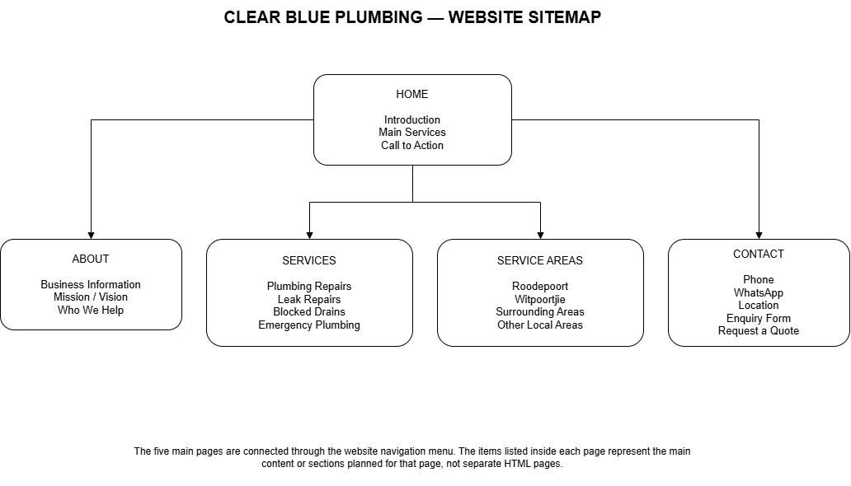

Low Fidelitiy Wireframes (1-5):

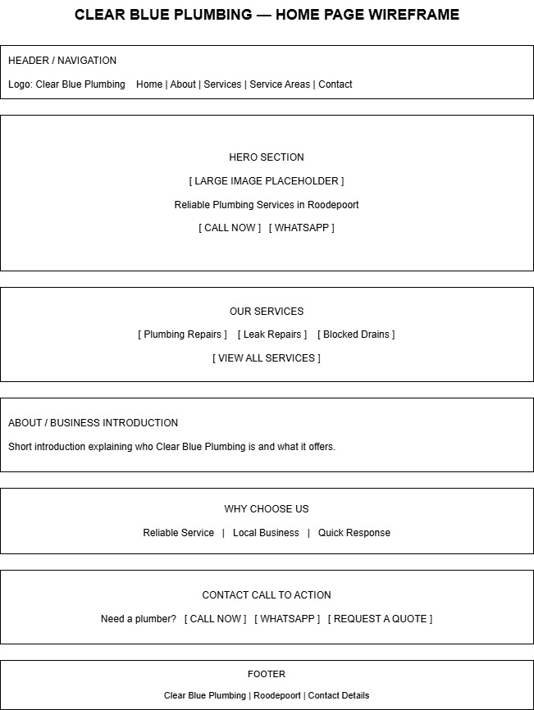
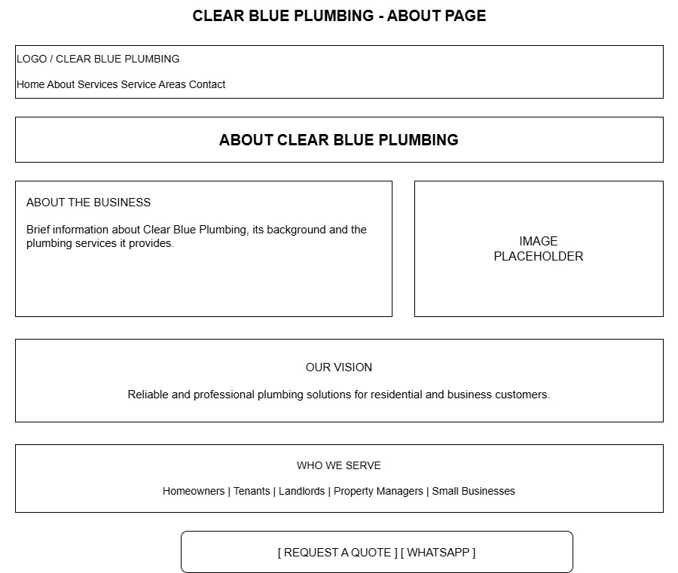
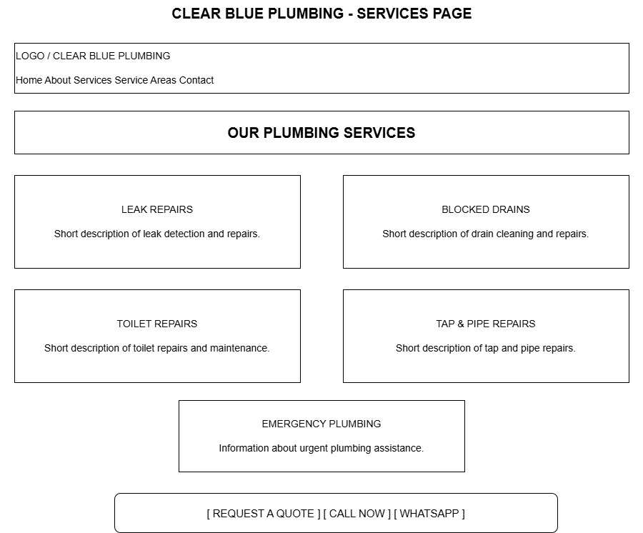
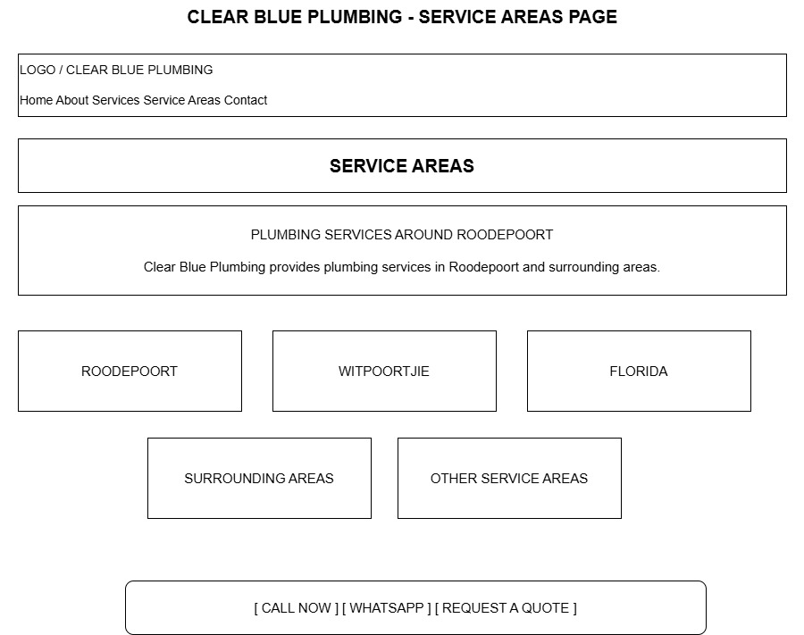
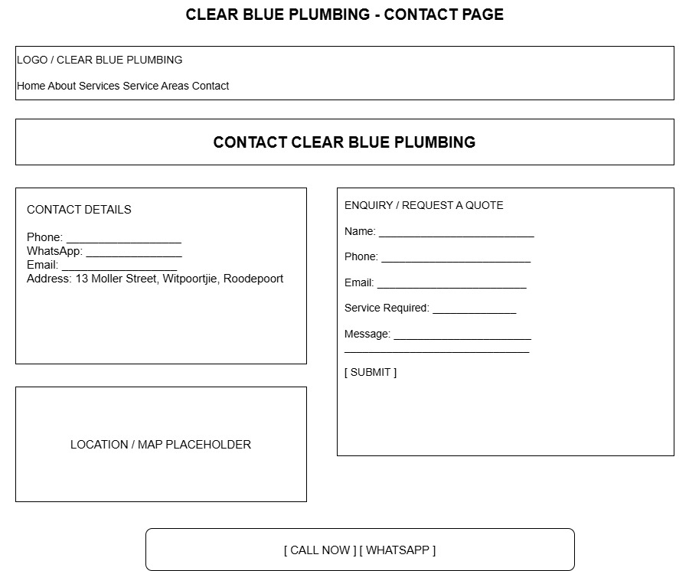

1.9 References

Clear Blue Plumbing references used for the proposal are all the sources used to research the organisation and its existing online presence, and sources used to support information for website development, search engine optimisation and web hosting.

Cybo. (2026). Clear Blue Plumbing – Roodepoort. Available at: Cybo (Accessed: 11 August 2026).

Google Maps. (2026). Clear Blue Plumbing, 13 Moller Street, Witpoortjie, Roodepoort. Available at: Google Maps (Accessed: 11 August 2026).

Google Search Central. (2026). SEO Starter Guide: The Basics. Google for Developers. Available at: Google Search Central (Accessed: 21 August 2026).

Google Search Central. (2026). Control your snippets in search results. Google for Developers. Available at: Google Search Central (Accessed: 21 August 2026).

Google Search Central. (2026). Influencing your title links in Google Search. Google for Developers. Available at: Google Search Central (Accessed: 21 August 2026).

Afrihost. (2026). Web Hosting. Available at: Afrihost (Accessed: 21 August 2026).

HostKing. (2026). Web Hosting. Available at: HostKing (Accessed: 21 August 2026).

Domains.co.za. (2026). .co.za Domain Registration. Available at: Domains.co.za (Accessed: 21 August 2026).

World Wide Web Consortium (W3C). (2026). Web Content Accessibility Guidelines (WCAG) 2.2. Available at: W3C Web Accessibility Initiative (Accessed: 21 August 2026).

Organisation 2: Cleantatiz

2.1 Organisation Overview:

Organisation Name:
Cleantatiz

Brief History:

Cleantatiz is a local cleaning company that offers cleaning and property maintenance services for customers who need help in keeping their home or business clean and presentable.

The business currently has an online presence but does not have a dedicated website. This restricts the information that prospective customers can access from a single source. Customers can only get basic info about Cleantatiz on the web, but they don't have a dedicated site where they can easily view the company's services, service areas, business information and contact options.

The website to be created will give the customer an information platform online, offering them opportunities to find out about the business and what cleaning services are offered, identify the areas of service and contact the business for additional information or a quotation.

For a cleaning company it would be very helpful for them to have their own website, as customers frequently like to know what type of cleaning will be provided, if the company does service their area and how they can get a price quote before booking a cleaning service.

Mission Statement:

Mission statement for Cleantatiz could not be found in public information researched.

Proposed Vision:

To offer clients reliable, effective cleaning for their homes and businesses and to make their professional cleaning more convenient, accessible and easy to arrange.

Target Audience:

The web page will address:

- Homeowners who need one off or regular cleaning
- Tenants in need of assistance with cleaning
- Property Owners in preparation for new tenants/occupants
- Landlords requiring cleaning between tenants
- Customers who need a deep or specialised cleaning
- Regular house cleaning is catered to for customers who are in need of it
- Commercial cleaning businesses and offices that need commercial cleaning services
- Property managers who are accountable for the maintenance of properties.Customers who need to have their home cleaned for a move in or out, when provided by Cleantatiz

2.2 Website Goals and Objectives:

The major function of the website is to create a professional online existence for Cleantatiz, simplify the accessibility of information and produce more enquiries from the customers.

The website will have the following objectives:

- Enhance the visibility of your brand, by developing your own website which can be indexed by search engines
- Proactively describe the available cleaning services, enabling prospective customers to have a clear understanding of what services Cleantatiz provides prior to contacting
- Create and send out enquiries and quotes with clearly visible calls to action.
- Make it easy for the business to be contacted with clear contacts such as phone, WhatsApp and enquiry form
- Build customer trust by giving customers professional information about the company, its services and, if available, customer reviews, photos and other trust information
- Optimize local search relevance by making sure that the areas where Cleantatiz operates are clearly identified
- Make it mobile friendly so customers can view the website and reach out to the business from their phones and tablets

Key Performance Indicators:

The following KPIs can be used to measure the effectiveness of the website:

- Number of visitors to your website (total website traffic)
- WhatsApp clicks
- Telephone clicks
- Contact form submissions
- Mobile usability
- Engagement

The following KPIs are more suitable to use than website traffic as the primary intent of the site is to ensure it gets visitors to contact Cleantatiz to request their cleaning services.

2.3 Current Website and Online Presence Analysis

Cleantatiz currently does not have a dedicated website. Although the business is online, there is no central website that potential customers can easily access where they can get a comprehensive overview of the business.

This has several restrictions.

Potential customers might have issues:

- Looking at all cleaning alternatives
- You should know what each service entails.
- Finding service-area information
- It is possible to learn more about the business.
- One place to find all contact information
- Quotation Request: filling out an online form to request a quote
- Looking at professional pictures or past work done
- Finding information on trust building like reviews or customer feedback

These limitations will be overcome in the proposed site by providing a 5-page site with a structured layout, including a Home page, an About page, a Services page, a Service Areas page and a Contact page.

The proposed website features and functionality:

The website will contain five main pages:

- Home
- About
- Services
- Service Areas
- Contact
Home Page:

The Home page will present Cleantatiz and clearly state the primary business value.

It will include:

- A clear introduction to Cleantatiz
- Main cleaning services
- Service-area information
- Professional cleaning imagery
- Key benefits or reasons to choose the business
- Call Now button
- WhatsApp button
- Request a Quote button

The most critical calls to action should be readily apparent and easy to spot without having to scan the page.

About Page:

The About page will give more information on Cleantatiz and what kind of cleaning services does it have.

If the information is supported by the organisation, then the page can contain:

- Company background
- Experience
- Cleaning approach
- Company values
- Staff information
- Professional qualifications or registrations required.
- Relevant photographs

No claims regarding qualifications, certifications, years of experience or company size will be added unless they are confirmed by Cleantatiz.

Services Page:

The Services page will show the primary services provided by Cleantatiz.

The following are potential categories that might be considered:

- Residential cleaning
- Commercial cleaning
- Office cleaning
- Deep cleaning
- Move-in cleaning
- Move-out cleaning
- Property cleaning
- Regular cleaning
- Once-off cleaning
- Specialised cleaning

The final list will be based on the services confirmed by Cleantatiz.

A brief description will be provided of each service detailing what this entails and who it is appropriate for.

It is backed by competitor research. Many cleaning websites in Gauteng nowadays tend to categorize the services into three sections, residential, commercial and specialised services, so that visitors can easily find the services of their interest.

Service Areas Page:

The Service Areas page will provide information on where Cleantatiz services are provided.

The main locations of services will be clearly defined and indicated. Other suburbs/areas will only be added once verified by the organisation.

It will also help their customers know if Cleantatiz services their location and will provide them with the page to use for local search visibility.

The website will not include repetitive pages for each suburb as this will not be useful information to the customer and will be a repetition of the same information with a different suburb name.

Contact Page:

The Contact page will be easy to use for potential customers to reach out to Cleantatiz.

It will include:

- Business telephone number.
- WhatsApp contact.
- If available, email address:
- Business/service location
- Service areas
- Simple enquiry form
- Request-a-quote option
- Map/location information where appropriate

The enquiry form may request:

- Name
- Contact number
- Email address
- Service required
- Location
- Preferred date
- Message/details

This information can assist Cleantatiz in understanding the customer's needs prior to responding.

Navigation:

Each of the 5 pages will have a consistent navigation menu.

The Footer will display:
- Cleantatiz name
- Contact information
- Navigation links
- Service-area information
- Copyright information
- JavaScript Functionality

Simple JavaScript will be used to:

- Contact-form validation
- Mobile navigation
- Interactive buttons
- User feedback
- Form error messages

2.5 Design and User Experience:

The website will have a clean, modern and professional look and feel which is suitable for a cleaning company.

Colour Scheme:

The proposed colour palette is to be:

- White
- Light blue
- Dark blue
- Light grey

Light and white hues will help to communicate cleanliness, and blue will give a professional and trustworthy look.

Typography:

- Poppins for headings
- Normal text is Inter

This mix will make for a contemporary look without compromising legibility.

User Experience:

The website will have a straightforward customer journey:

Identify the website → Become familiar with the service → see the service area → request a quote or contact Cleantatiz

The most important actions will be seen across the entire site:

- WhatsApp
- Call Now
- Request a Quote

The design should not be too complex as the customer wants to know what the service is and contact the cleaning service as soon as possible.

Responsive Design:

The website will be responsive and responsive to the following:

- Smartphones
- Tablets
- Laptops
- Desktop computers

It will be especially crucial for mobile optimisation, as customers might look for cleaning services from their mobile devices.

Accessibility and Usability:

Basic accessibility principles will also be taken into account.

These will include:

- Readable font sizes
- Good colour contrast
- Descriptive image alt text
- Form fields that are clearly labelled
- Visible buttons
- Clear error messages
- Consistent navigation
- Interactive components that can be accessed using the keyboard where applicable

2.6 Technical Requirements:

The website will be developed using:

- HTML
- CSS
- JavaScript
- Use of version control

Where appropriate, semantic HTML elements will be used, such as:

- Header
- Navigation
- Main
- Section
- Article
- Footer
- Form

2.7 Timeline and Milestones:

Week 2: Research and Planning

- Do an online search
- Do some research into the cleaning industry and some competition
- Determine the audience
- List the types of common cleanings
- Determine website goals and KPIs
- Collect validated Cleantatiz data
- Determine needed content
- Complete the organisation proposal
- Set up the first repository on Github

Week 2: Sitemap, Wireframes and Content
- Determine the layout of each page
- Decide on colour scheme and typography
- Collect and structure information from websites
- Capturing and improving images.
- Plan the calls-to-action.Verify service and contact details.

Week 3: HTML Files Development

- Produce the 5 HTML pages.
- Create header and nav.
- Create Home page.
- Create About page.
- Develop the Services page.
- Develop the Service Areas page.
- Develop Contact page.
- Add researched content.
- Add images.
- Connect navigation links.
- Use semantic HTML.
- Push changes to GitHub.
- Milestone

Week 4: CSS, JavaScript and Responsive Design

- Use the colour scheme.
- Apply typography.
- Style the navigation.
- Style service sections/cards.
- Create responsive layouts.
- Implement mobile navigation.
- Style calls-to-action.
- Add ‘Add WhatsApp’ and ‘Add a phone number’ buttons.
- Implement basic JavaScript.
- Add contact-form validation.
- Optimise images.
- Include simple SEO components.
- Try out various screen sizes.
- Milestone

Week 5: Testing, Optimisation and Documentation
- Test all 5 pages
- Test on desktop, tablet and mobile
- Test in Chrome and Edge
- Proof-read for spelling and grammar errors
- Review images and alternative text
- Check HTML/CSS/JavaScript errors
- Fix bugs
- Optimise page performance
- Check the final website with the proposal
- Make final GitHub commits
- Make final product ready for delivery

Development Process:

The general development process will then be as follows:

Research, Planning, Sitemap, Wireframes, Content, HTML, CSS, JavaScript, Responsive Design, SEO, Testing, Documentation, Deployment

This offers a more realistic development process and minimises the risk of major changes being needed after the website has been coded.

2.8 Budget:

Hostking offers its Launch package at R69/month R414/year when billed annually and comes with the following features: SSL, 50 GB NVMe storage, unlimited bandwidth and a free domain on annual plans.

Currently, Afrihost is offering shared hosting that starts from R84 per month, and a free qualifying domain for the first year. It is available at a basic level with Linux operating system, 2GB storage space and 50 email accounts.

Proposed Budget:

Estimated Cost:

- Website development, Development and design, R4,500
- Price R414/year Hostking
- A qualifying Hostking annual plan includes .co.za domain..co.za domain is included in a qualifying hostking annual plan
- Basic maintenance- R1000/year
- Estimated first year total-R5,914

Alternative Hosting Option
Afrihost:

Estimated Cost:

- Website development R4,500
- Afrihost hosting-R84 × 12 = R1,008
- Qualifying .co.za domain-Free first year
- Basic maintenance-R1,000
- Estimated total of all first year expenses-R6,508

Afrihost confirms that its shared hosting starts at R84 per month and that qualifying .co.za domains are free for the first year with shared hosting.

Development Cost

The proposed development cost of R4,500 is for the following:

- Project planning
- Website design
- Five page website development
- HTML development
- CSS styling
- Responsive design
- Basic JavaScript functionality
- Contact form
- Basic SEO implementation
- Image optimisation
- Browser testing
- Mobile testing
- Bug fixing
- Basic deployment assistance
- Maintenance

The suggested cost of maintenance is R1,000.00 per annum and this includes the following basic updates to the website:

- Minor text changes
- Updating contact details
- Updating service information
- Replacing images
- Minor content changes
- Basic troubleshooting

Any additional pages, website redesigns, online booking systems, advanced forms, payment feature, or continuous SEO campaigns would be extra pricing.

Sitemap:

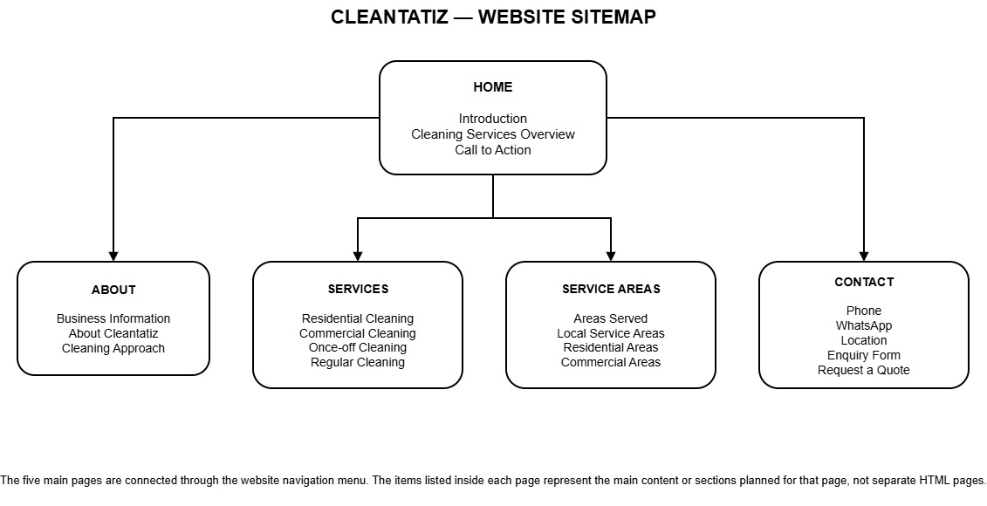

Low Fidelity Wireframes (1-5):

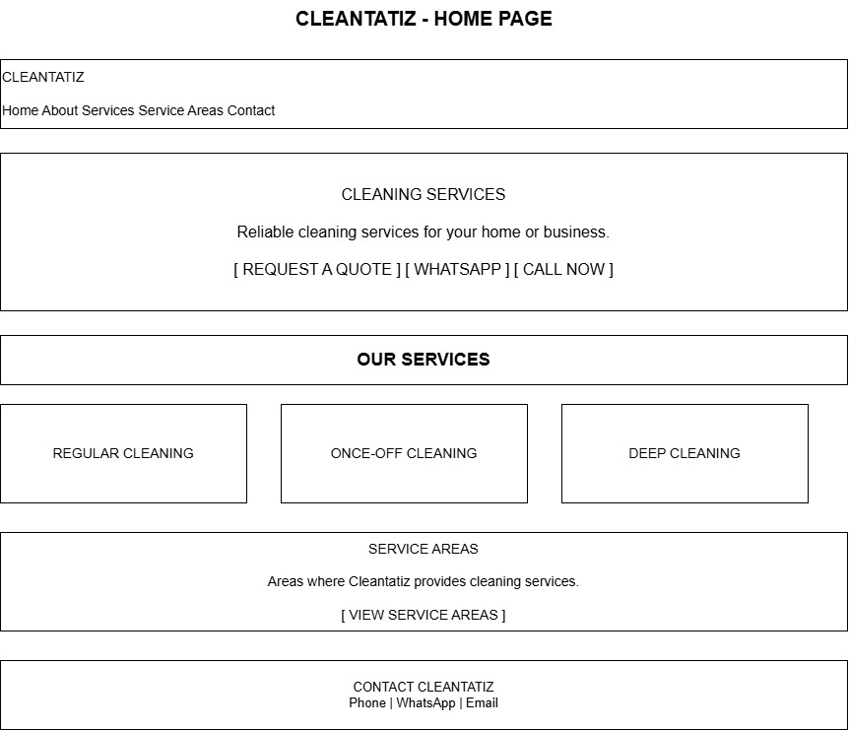
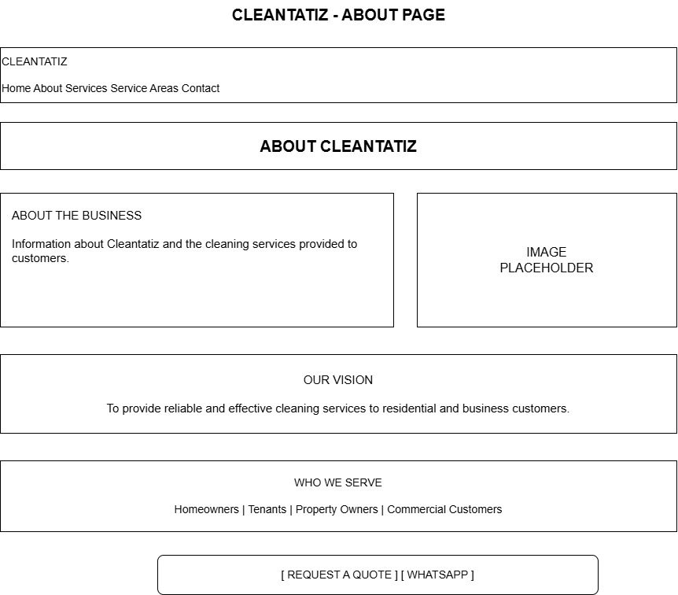
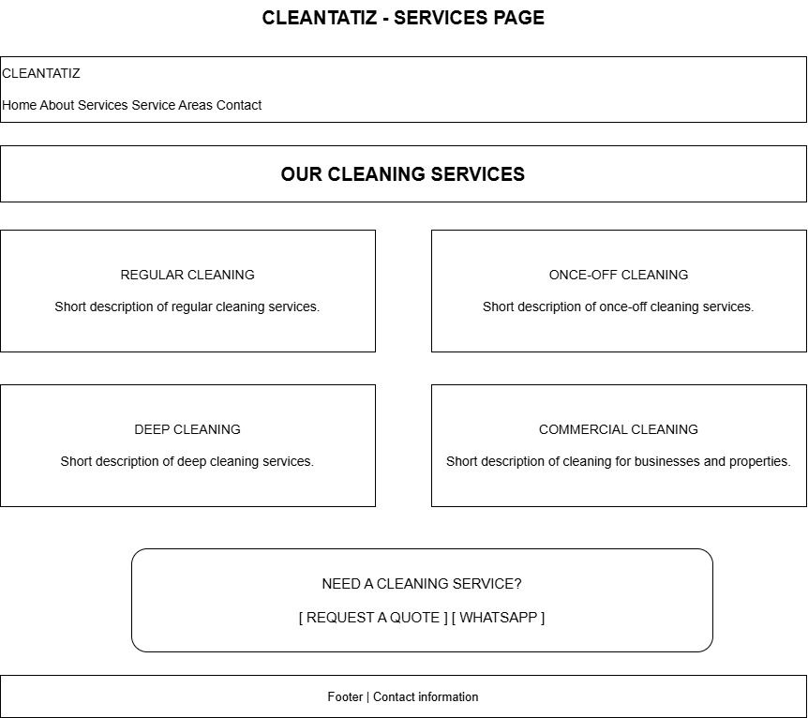
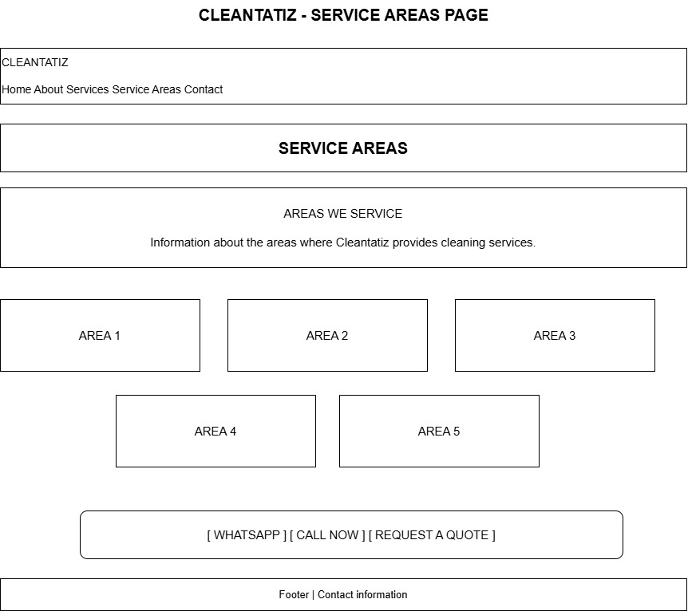

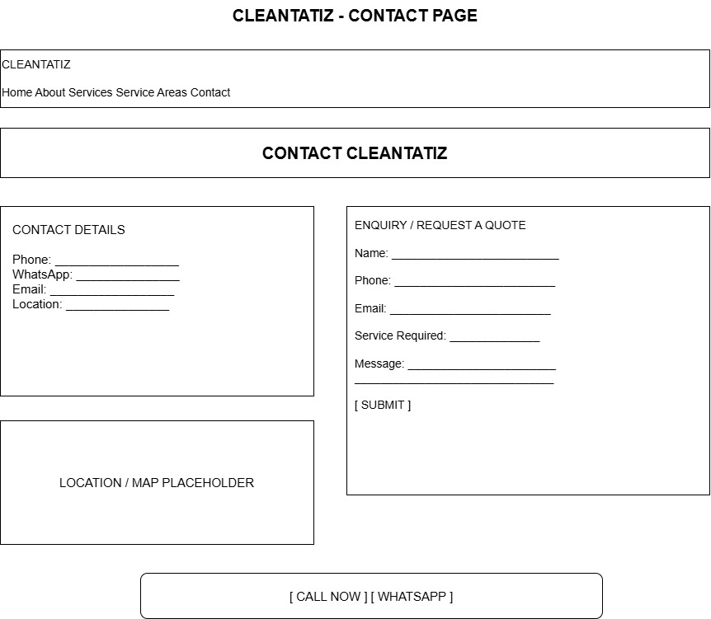

2.9 References
The following references have been provided in regards to the Cleantiz proposal research into the current online presence, the organisation and online sources used to support information regarding website development, Search engine optimisation, Accessibility and web hosting.
- Google Maps. (2026). Cleantatiz business listing. Google Maps. Available at: Google Maps (Accessed: 11 August 2026).
- Google Search Central. (2026). SEO Starter Guide: The Basics. Google for Developers. Available at: Google Search Central (Accessed: 21 August 2026).
- Google Search Central. (2026). Control your snippets in search results. Google for Developers. Available at: Google Search Central (Accessed: 21 August 2026).
- Google Search Central. (2026). Influencing your title links in Google Search. Google for Developers. Available at: Google Search Central (Accessed: 21 August 2026).
- World Wide Web Consortium (W3C). (2026). Web Content Accessibility Guidelines (WCAG) 2.2. Available at: W3C Web Accessibility Initiative (Accessed: 21 August 2026).
- Web Hosting South Africa. (2026). Web Hosting. Available at: Web Hosting South Africa (Accessed: 21 August 2026).

